**ASSIGNMENT 1**

1.Write a python program to interchange first and last in a list.

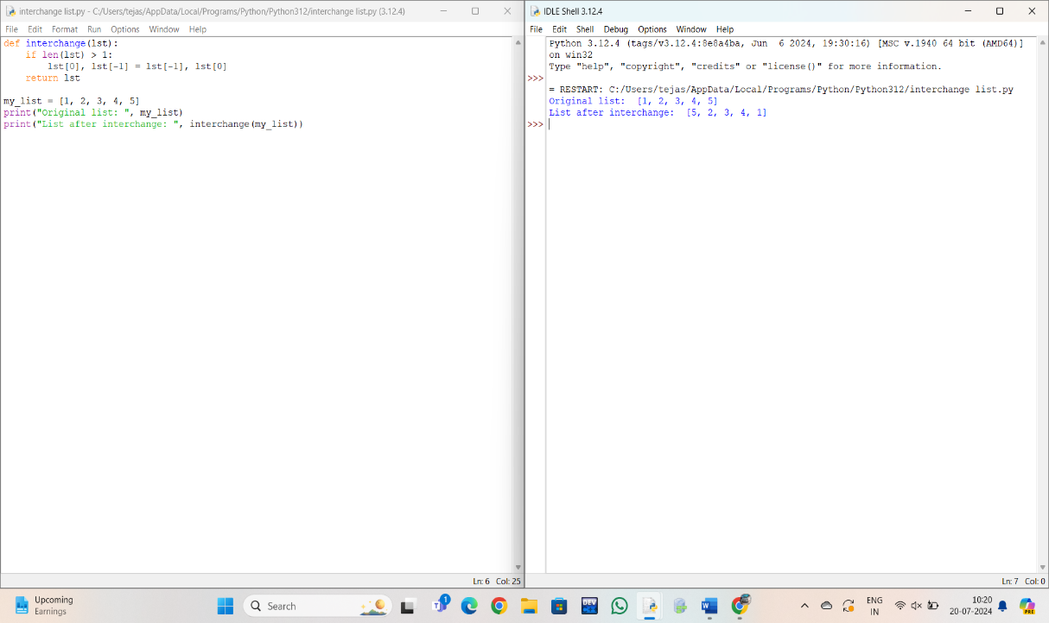

22222.To swap to two elements in a list.

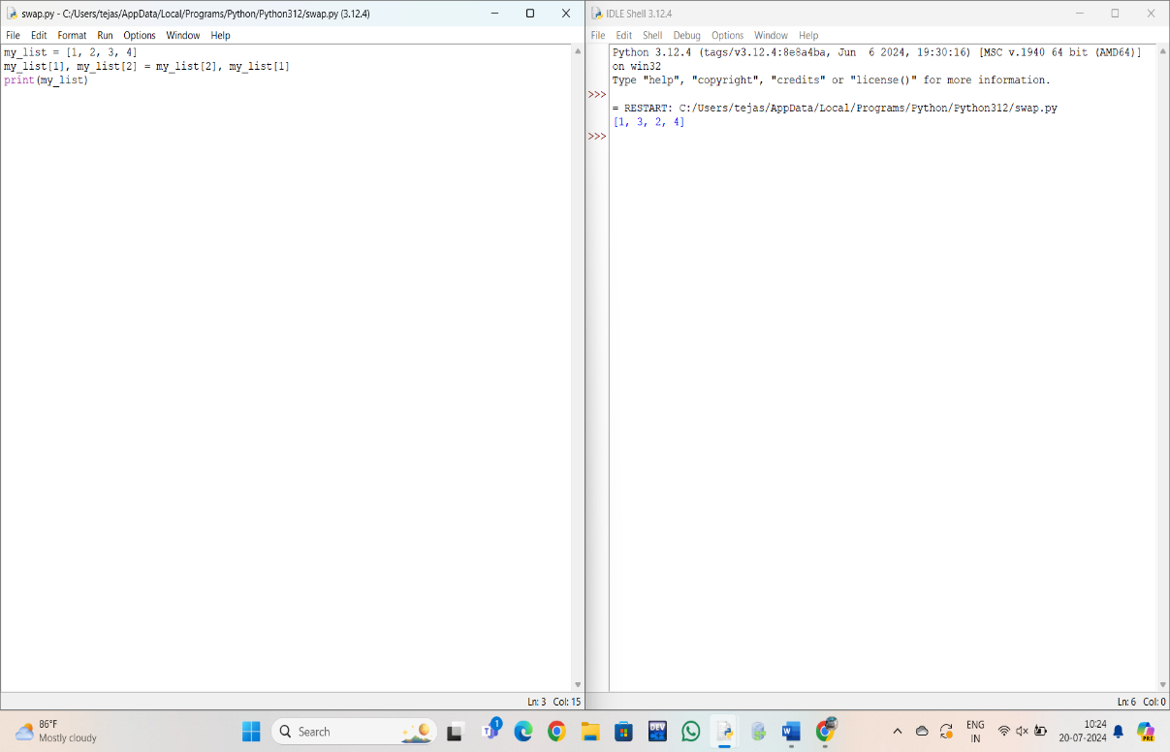

3.Reverse words ina s string in python**.**

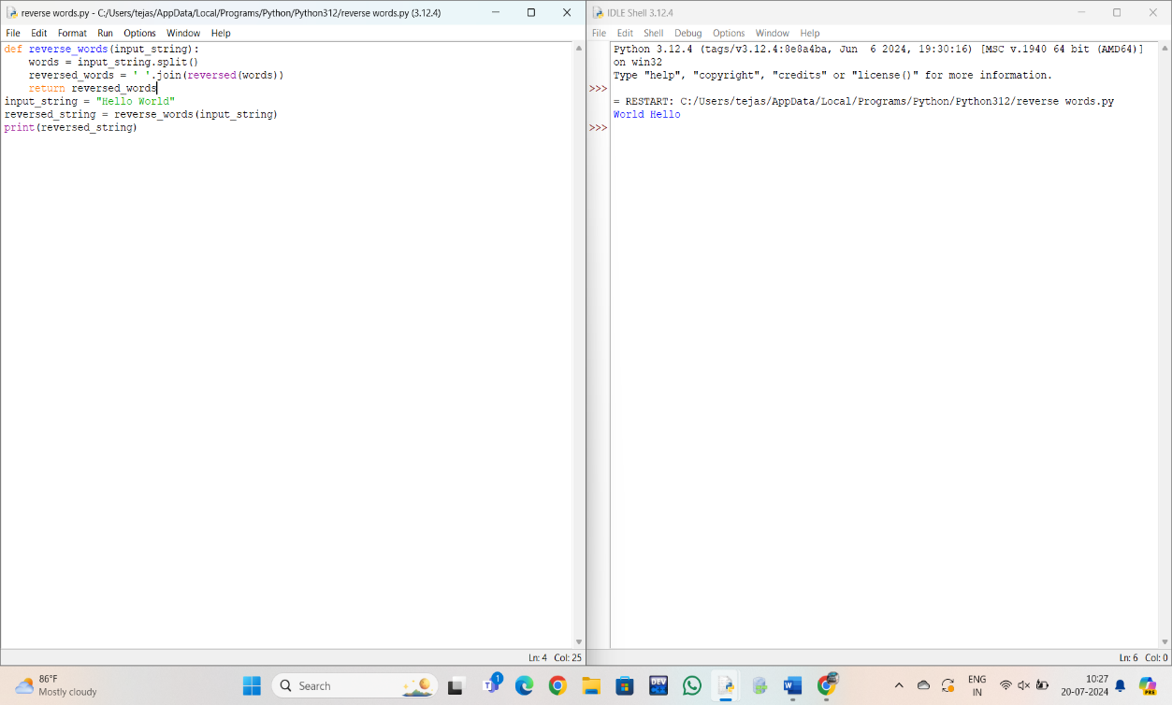

4. find length of string in python.

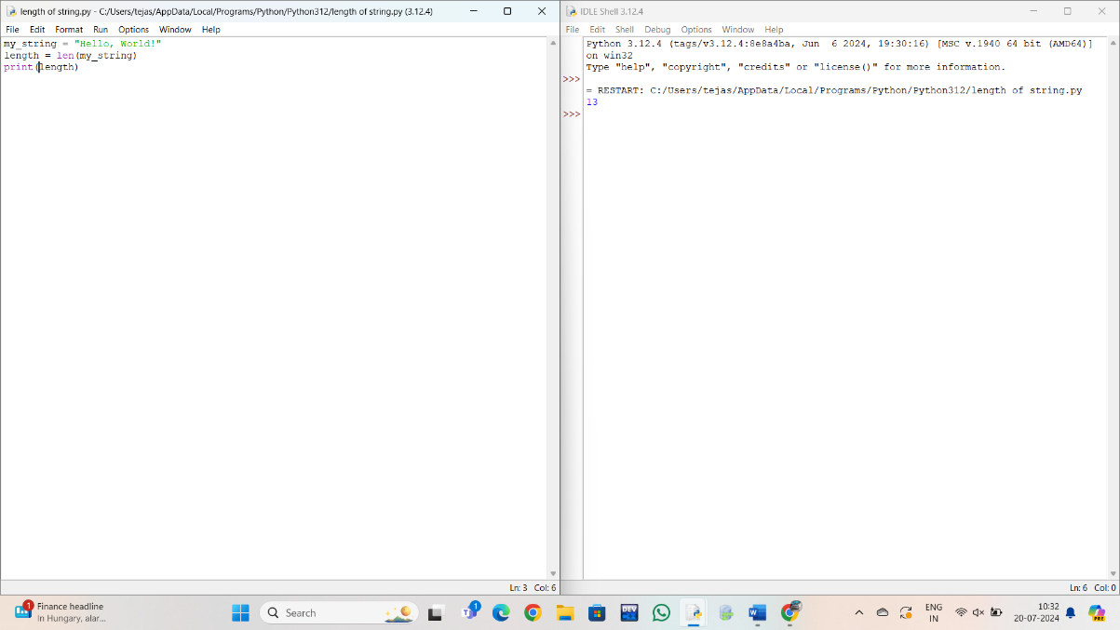

5.To find maximum and minimum kth element in pupil.

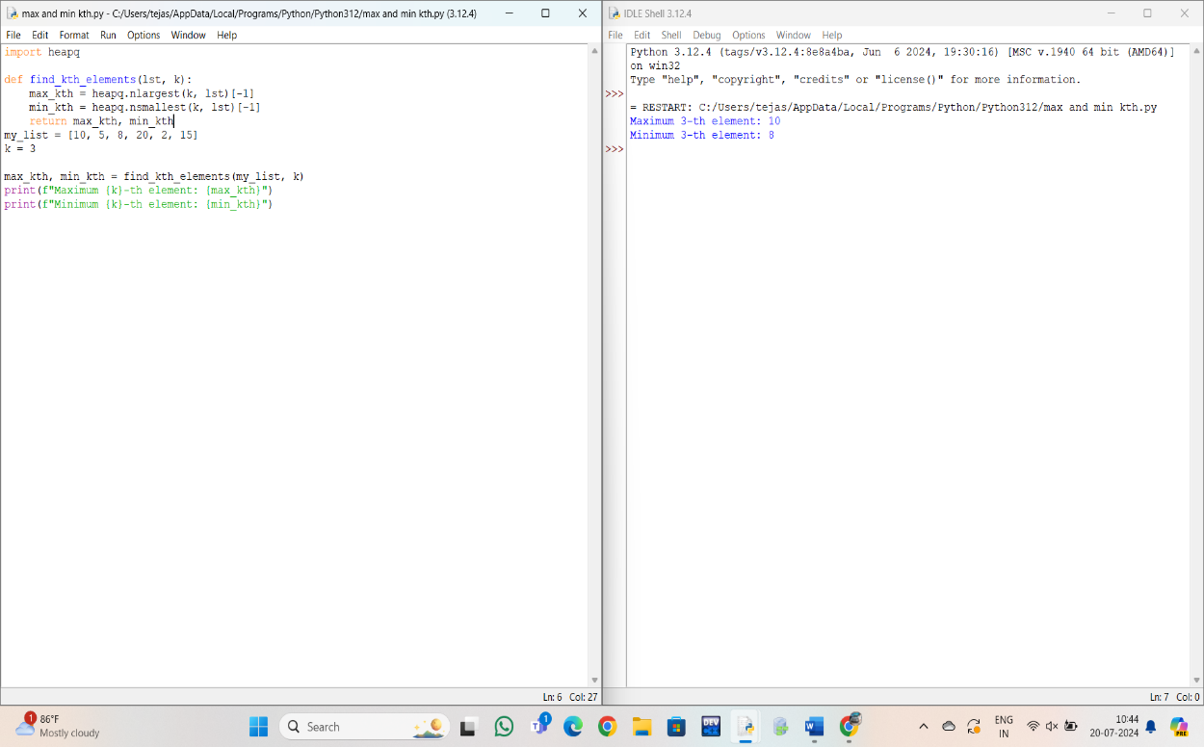

6.To find sum of all items in a dictionary.

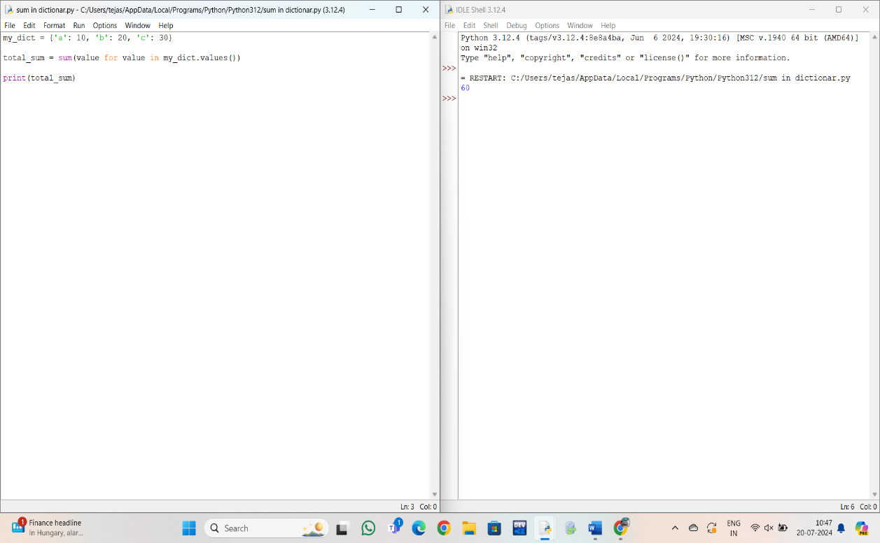

7. Remove item from set.

